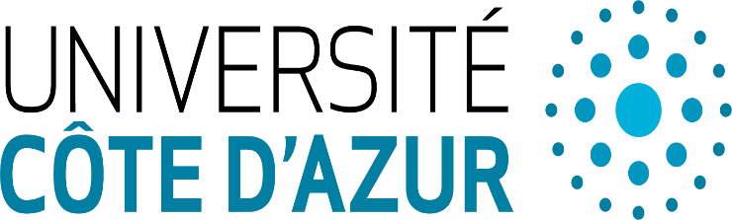

Quantum complexity theory

CLÉMENT MARIA

Abstract : In this talk, we will introduce standard notions of classical and quantum complexity theory, notably the complexity classes P, NP, #P (classic) and BQP (quantum), as well as standards theorems such as the Solovay-Kitaev theorem. Along the way, we will introduce the notion of quantum circuit as model of quantum computation, and highlight similarities and connections between the classical and quantum complexity classes. If time permits, we will illustrate these notions with natural computational problems from knot theory.

